This report addresses the principle and the need of the community and their support regarding the redevelopment of Laasqoray Jetty.

We have divided this report to include the following sections:

- Technical Issues: ships, berths, wave conditions, geo-technical conditions, construction scenario and phase selection with cost estimates
- Funding
- Governance, ownership, and management
- Mitigating risk
- Horn Relief “capacity statement”

We also attach the following for your further information:
- Annex A: Declarations and letters of support from the Sultan, the President of Somaliland and Vice-President of Puntland, and regional Chiefs and Elders
- Annex B: Script from Primary School play about Jetty use
- Annex C: Photographs from May 30th community meeting in Badhan
- Annex D: Presentation made at community meeting
- Annex E: Response by Graeme Watson Associates
- Annex F: List of Diaspora contacts in the USA, UK, Canada and elsewhere

Technical Issues

Both Graeme Watson and Associates and DHV support the structure and berthing facility as well as the approach to construction and dredging. We attach Graeme Watson Associates’ response to the DHV report as Annex E.

Naturally, we will rely on the detailed “design stage” to make specific analyses of issues like ships, berths, wave conditions, geo-technical conditions, though we plan to undertake aspects of these prior to the design stage.

Construction type and Schedule
Seven options were proposed for the jetty design. For Phase I design, three options were suggested. For Phase II, four options were described. The options are:

- Phase 1 port works without deepening by dredging;
- Phase 1 port works with deepening by dredging;
- Phase 2 port works without deepening by dredging;
- Phase 2 port works with deepening by dredging;
- Phase 2 port works without deepening by dredging following Phase 1 with deepening by dredging;
- Reduced scope Phase 1 port works with deepening by dredging;
- Reduced scope Phase 2 port works with deepening by dredging.

Horn Relief is satisfied that both the Feasibility Study (Graeme Watson Associates) and the DHV report have identified the appropriate construction type for this Jetty. Both reports concur that a Jetty comprised of “pre-cast block wall protected with sand fill and protected by rock cover on the seaside” (DHV pg. 15 and Feasibility Study 3.4.1) represents the most cost efficient of the seven options and will build major and minor berths with appropriate characteristics for the Red Sea coast. The proposed berths have the following characteristics:

 | Description | Minimum water depth (m) | Length (m) | Apron
 |  |  |  | Height above datum (m) | Width (m)
Phase I | Minor berth | 3 | c.50 | 4 | 15
Phase I | Minor berth | 2 | c.50 | 4 | 15
Phase I | Minor berth | 1 | c.50 | 4 | 15
Phase II | Major berth | 6 | 120 | 4 | 20
Phase II | Major berth | 4 | 100 | 4 | 20

Phase I (layout 6) includes “Minor Berths” that will be used for berthing small vessels and may also be used by larger vessels when not fully loaded or at periods of neap tides.

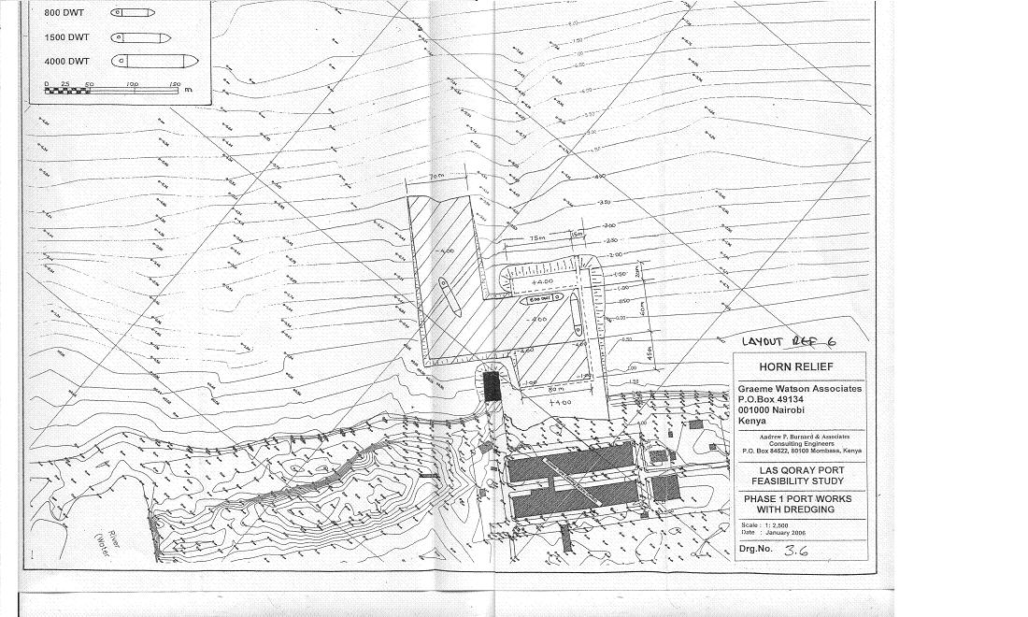
Phase II (layout 7) includes “Major Berths” that will allow two 3,000 DWT vessels to berth there together or one larger vessel to berth when not fully loaded or at periods of neap tides.

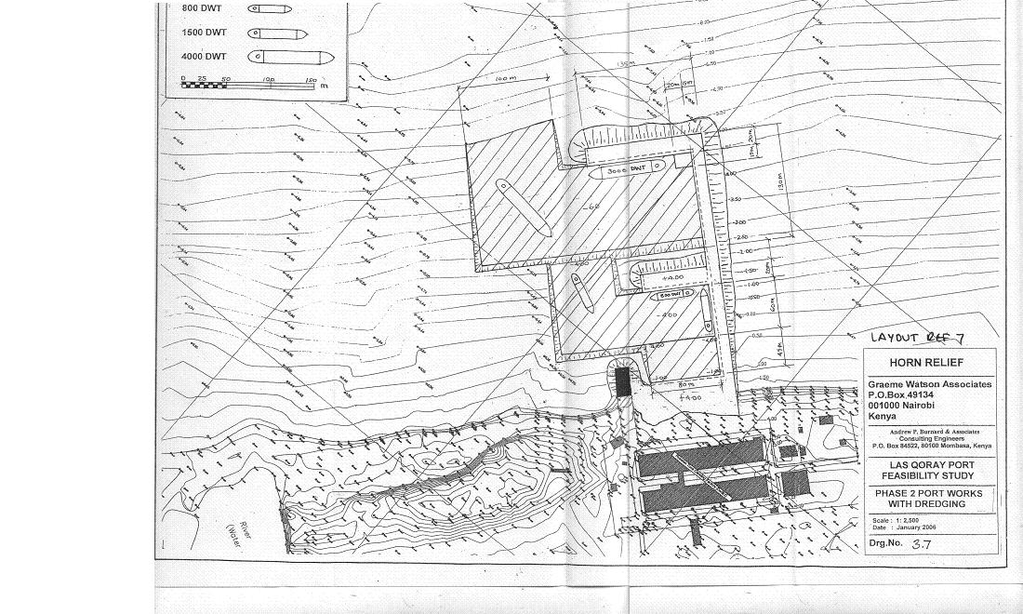

Funding

As a first step, Horn Relief is now developing an [Outreach Strategy] to achieve two specific outcomes:

- Ensure that the project secures all the funding it needs to complete the construction and initial operation of the Jetty
- Ensure that local communities are fully engaged in the project and commit to maintaining peace and security in the region
To implement the [Outreach Strategy], we are forming the non-profit Jetty Foundation (JF) that will use the Strategy to reach out to local communities, Diaspora, international donors, the private sector, etc. The JF will be incorporated in both Somaliland and Puntland and an internationally in the USA, Canada or a country in Europe and have function headquarters in Badhan, Sanaag and include local staff as well as Diaspora from overseas

We are writing the [Outreach Strategy] to include these elements:

FUNDING | PEACE AND SECURITY
- Employing our energetic Board of Directors in the USA to liaise with the identified Diaspora representatives listed in Annex F to support the project;  - Engaging an influential and locally-engaged businessperson (Omar Abdi Ali Bayr) who has approached Horn Relief with an offer to raise substantial funding through Diaspora;  - Presentations to Arab donors such as the Islamic Development Bank (IDB), Kuwait Fund for Arab Economic Development (KFAED), etc.;  - A possible joint Novib / Horn Relief funding mission to Somalia-friendly donors; and  - Submissions to the JNA, which has placed an emphasis on infrastructure and includes the jetty as a candidate for funding. | - Organising regular meetings with Chiefs to assist in their outreach to communities;  - Providing literature and techniques for Chiefs to meet with communities and encourage understanding and awareness of this community asset;  - Engaging PYL (Pastoral Youth leadership) youth to keep Chiefs informed of progress-to-date;  - Hire a Foundation “Envoy” to report to/liaise with Sultan and Puntland & Somaliland authorities and maintain open communications with Chiefs and Elders;  - Sponsor biweekly conference calls between Foundation and Diaspora network for security updates; and  - Maintain updates and news on Horn Relief website.

Governance, ownership, and management
Gender Equality

Women have always had a unique and powerful role in governance and management, especially in terms of conflict resolution. Somali society values the participation of women. Their role in this project is not only critical, but inspiring. Women associated with this project will have an influential impact on female participation in projects in their communities. We know that the greater the involvement of women as leaders, trainers and coaches, the more effective is the learning and the greater is the use of innovations in pastoral economies.

Horn Relief has a demonstrated commitment to gender equality both as a principle and as an effective poverty reduction strategy. Within the Jetty project, gender will be a specific priority:

- Equitable participation of women will be a criterion in the selection of committee members and staff/workers;
- Local organisations will be encouraged to balance the assignment of women and men for Jetty-related activities;
- The project will pay particular attention to linkages with women’s groups and those NGOs and donors with gender programs; and
- Statistics reflecting gender balance will be maintained for all project activities and corrective action will be taken should imbalances develop.

There are four major ports in Somalia that, at one time, fell under Somali Ports Authority Mogadishu, Berbera, Kismayo and Bossaso. The first three are deepwater ports, the latter is the fastest growing port in Somalia. All of these ports now fall under independent port authorities set up by local clans and government authorities, while the smaller ports such as El Ma'an and Merka fall under the influence of clans and businesspersons.

We do no wish to have this infrastructure controlled by one specific segment of the population, so we will be depoliticising it by laying the foundations for collaborative governance, ownership, and management. This means building consensus between clans, the Puntland and Somaliland authorities, Diaspora, the private sector, and communities.
We began the process of launching governance and management bodies with four interventions:

- Dialogue with Somaliland and Puntland administrations
We have engaged both Presidents and have obtained letters from each administration. But we understand that dialogue must continue and are committed to communicating project progress to these administrations regularly.

- Conference call with international Somali Diaspora
The conference call on May 30th resulted in obtaining unanimous commitment from 16 Diaspora representatives (see Annex F) who will advocate for support of the Jetty and are ready to fundraise on its behalf. This strong show of support from Diaspora across three continents is impressive and continues to build – we expect that this group will generate significant funding from the Somali community around the world.

- Meeting of elders to achieve consensus on significant issues related to the Jetty
On May 31st 2006, Horn Relief organized a meeting of Laasqoray and North coast elders in Badhan, Sanaag. Over 120 elders from as far away as Erigavo and Mudug attended the meeting. Horn Relief presented the gathering with an update on the jetty project and asked for community-level support to ensure the management, security, and use of the Jetty is equitable and peaceful. Attached to this letter is the full declaration (Heshiis) signed by more than 75 community members, elders, chiefs, and sultans. A separate letter of support was signed by the Sultan of the Warsengeli clan – leader to more than 225,000 people in the North of Somalia and an estimated 75,000 Somali Diaspora.
In addition to the support voiced by so many leaders in the region, Horn Relief is following up the meeting with an invitation to establish a governing body (in the Somali tradition) to advise on project implementation.

- Meetings with the Sultan to establish dialogue, understanding and commitment
We are pleased with our discussions with the Sultan. He received Horn Relief staff readily and attended the community leaders meeting in Badhan on May 31st.
Our initial meetings resulted in the Sultan signing a commitment letter (attached as Annex A). Horn Relief appreciates this support and is committed to an open and regular dialogue with the Sultan to ensure continued support and his influence on peace and security in the region.

Horn Relief understands how important community awareness and support is to effective management of projects – it is a significant component in all our programming. As well, we understand that this Jetty does not represent a “Horn Relief project” instead we aim to put Laasqoray in the “driver’s seat” by creating three governing/management not-for-profit corporations to manage different aspects of the project:

- Laasqoray Jetty Development Committee (JDC) to govern and oversee the pre-construction, construction and overall management of the Jetty.
- As subsidiary of the JDC, the Laasqoray Jetty Authority (JA) will oversee the day-to-day operation of the Jetty
- Also a subsidiary of the JDC, the Laasqoray Jetty Foundation (JF) will assume ownership of the Jetty, implement the outreach strategy and manage revenue stemming from Jetty operation
A fourth body, the Community JDC (CDC), is already in place and will assume the Jetty project as an added element to its overall mandate.

The importance of the composition of these multi stakeholder management bodies and the seriousness with which stakeholders in the North coast approached this issue cannot be overemphasized. Not surprisingly, the composition of these governing bodies is perhaps the single most important factor determining its effectiveness and support by local stakeholders. Jetty stakeholders indicated during the Badhan May 31st meeting that they realize the composition of these bodies is tremendously important and must be carefully considered.

This simple organization chart shows the proposed relationships between entities. All are blend of traditional Somali approaches to governance and contemporary enterprise management. These bodies are truly egalitarian in composition involving government, civil society, cultural leaders, and community members. We already have the commitment of leaders in the region to manage this community asset by way of community involvement, regardless of clan. We anticipate soon drafting a [Charter] to describe how these bodies will work together and where and how decisions are to be made.
The model proposed here is similar to the model proposed in the Socio-Political Conflict Assessment (Wachiira and Baffo), with some differences.

Horn Relief Model | W&B Model | Differences
Jetty Development Committee (JDC) | Project Steering Committee | - Similar but JDC will be mandated to oversee project implementation and continue post construction to govern Jetty operation and planning
Jetty Authority (JA) | Executive Committee | - Similar except the JA includes a board and staff
Jetty Foundation (JF) |  | - New body to “own” the Jetty and manage fiscal aspects (fundraising and revenue sharing)  - Includes W&B’s Community Development Fund (CDF) function because the JF will function as a typical development foundation for communities
Community Development Committee (CDC) | Shir (Forum) and Advisory Committee | - The CDC is already established and encompasses functions of the Shir and Advisory Committee
Horn Relief’s Jetty Management Team | HR’s Jetty Project Management Unit | - Similar

Horn Relief is proposing this model with the following elements:

- Jetty Development Committee (JDC)
The Jetty must have an overall governance directorate that is mandated to make final decisions on Jetty management and development. The JDC will be created to fulfil this role. It will be governed by a constitution and a twenty-member board of directors to include a wide range of stakeholders (e.g. CDC will elect clan members, government, private sector, civil society, etc.).

Note: We have included two Government representatives (Puntland and Somaliland) in this twenty-member board to ensure full transparency and improve information sharing. These two representatives of the authorities will be invited to all JDC meetings and will have access to the same information provided to all JDC members and can even participate in the debate on topics. However, they will hold observer status in the JDC and will have no vote on decisions. Our strategy remains a community-owned Jetty, but we feel all stakeholders need to be included in the process to mitigate risk. Our experience has been that misinformation is possible if stakeholders are left out of the process. The Jetty ownership will remain at the community level (in the JF).

- Jetty Authority (JA)
The Jetty will need a management body to manage the day-to-day running of the Jetty. As with any port, wharf, or jetty, an “Authority” manages the smooth operation of all Jetty business. The JA is a subsidiary of the JDC and will be subject to its authority.

- Jetty Foundation (JF)
Fulfilling both a fundraising and fiscal management function, the Foundation will also be the legal owner of the Jetty. A board of directors will control (but not “own”) the Jetty and will arrange leasing to the JA. Established as a subsidiary of the JDC, the JF will report directly to the JDC though the JF will have independence on issues of revenue sharing.
We understand the Wachiira and Baffo recommendation that: “… port ownership lies with the community of Laasqoray and the larger Warsangeli clan, who would be the primary stakeholders” but find this model of “communal ownership” to be impractical and prone to manipulation. We feel that “shares” of the Jetty could be bought and sold and some groups may be tempted to consolidate shares to control the Jetty. We consider the most egalitarian and least contentious model of ownership is one that has ownership held “in trust” by a non-profit corporation. This is typical practice with foundations around the world with management of funds or assets being guided by a professional and accountable board of directors.

- Community Development Committee (CDC)
The CDC is already established. It has been created by the community as a place for discussion and debate about community-based development in the region. The CDC is chaired by the Sultan and includes membership from all the regional clans. The CDC would fulfil a critical advisory role in any governance/management model adopted for the Jetty, and is included in this structure to provide important cultural perspective to Jetty governance.
A critical function of this body will be to provide risk assessment and conflict mitigation/resolution counsel to the JDC.

Jetty Development
Committee (JDC)
Jetty Authority (JA)
Jetty Foundation (JF)
Community Development Committee (CDC)
Governance
Management
Ownership

The CDC will hold an initial large Shir (Forum), which is the traditional mechanism for governance and conflict resolution, whereby a comprehensive Heshiis (contract or agreement) will be develop that will sanction the proposed structures. The Heshiis will be an overarching agreement that will encompass several sub-agreements for all the bodies/structures proposed. The CDC will hold a biannual Shir, chaired by the Sultan, to review progress and performance, discuss security issues, and review (annually) the membership of the JDC and JF board members.

The Heshiis will encompass the following agreements in which the bodies will be guided by:
- [Jetty Charter]: how each of these entities will work together
- [Bylaws]: two sets of Bylaws will be developed that will govern both the Jetty Authority (JA) and the Jetty Foundation (JF).
- [Revenue Sharing Agreement]: a critical agreement needing finalisation before this project begins construction that will guide the work of the Jetty Foundation (JF)
- [Jetty Development Strategy]: a plan for the JA to build and grow into the future

To participate fully in all aspects of the project, Horn Relief will bolster its technical and project management capacity by hiring a Senior Project Manager and an experienced Marine Engineer. Horn Relief will also recruit a Project Officer who will have expertise in conflict resolution, community asset management and participatory approaches that can lead and facilitate the consensus building process whereby the Shir and Heshiis are developed. Together with a Senior Finance Officer, Horn Relief will have a highly skilled and competent Jetty Management Team (JMT) to ensure efficient and accountable project management. One of the key responsibilities for the JMT is the development of a Horn Relief exit strategy and full handover of the project and all it’s responsibility to the community. However, we anticipate that the process of handover will take approximately 5 years after construction of the facility.

Finally, Horn Relief will be a member of the structures and have voting rights on all the boards.

Governance

The Feasibility Study (Section 5.9.3) states: “The stakeholders who were contacted in the course of carrying out the feasibility study were unanimous that the proposed Jetty should be managed as an autonomous institution along commercial principles.” We support this view and see strong business-oriented operation as a must. It is for this reason that have placed emphasis on the type and quality of members to various structures, particularly management board of directors for the Jetty Foundation and Jetty Authority must be people with high level of technical and business skills.

Community Development Committee (CDC)

Members
Sultans
Chiefs
Elders

There already exists a CDC in Badhan that have accepted the Jetty as a new element of their work. Its makeup is Sultans, Chiefs, and Elders in the region and has membership from the following clans:
- Warsangeli
- Isaaq
- Dhulbahante

The CDC will adopt the Laasqoray Jetty as a community project and will provide advisory services to the Board in the following areas:
- Conflict mitigation and security
- Social development projects

Conflict mitigation and security
The CDC will work closely with the JDC to ensure that all elements of the Heshiis are effectively being adhered to and will play a key role in solving potential conflicts or problems early to ensure that these conflicts do not escalate. It is the role of the CDC to utilize effective traditional conflict resolution mechanisms to resolve problems as early as possible with the JDC.

Social Development projects
The CDC will advise on appropriate local development projects that will be balanced (vis-à-vis clan) and address the long-term development needs of the region.

Additionally, Horn Relief has contacted UN Habitat’s Urban Management Programme Office in Nairobi to discuss using their “participatory urban decision making” methodology. We acknowledge that competent local governance will be an important catalyst for local development in Laasqoray. It will ensure that the Jetty is managed in a responsible and secure manner. We will work with the CDC to facilitate this local governance structures.
As well, we expect that growth in Laasqoray and surrounding areas will mean a significant growth in population of the town and an expansion of dwellings into outlying areas and a possible uncontrolled expansion challenging the environment and provision of essential social services.
With the expected focus on revenues for social projects in the town, we anticipate needing an urban plan to control development in the town as well as plan for social services like police, health clinics, road infrastructure, etc. These are areas in which we could work with UN Habitat in developing.

Jetty Development Committee (JDC)

Jetty Development Committee
Member | Stakeholders represented/key functions on board | Member | Stakeholders represented/key functions on board
Diaspora | Regional Somali representative in USA. Assists with Board operation, accountability and lends it significant political leverage. | Local Community | Represents aspirations of 30,000 community members and brings priorities to the board. Communicates PDC policies to villagers. Helps the Board make decisions in relation to community needs and activities.
Diaspora | Regional Somali representative in Europe. Assists with Board operation, accountability and lends it significant political leverage. | Local Community | Represents aspirations of 30,000 community members and brings priorities to the board. Communicates PDC policies to villagers. Helps the Board make decisions in relation to community needs and activities.
Diaspora | Regional Somali representative in Canada. Assists with Board operation, accountability and lends it significant political leverage. | Erigavo business leader | Co-Chair from regional trade group. As Co-Chair, shares leading of monthly meetings. Key stakeholder supporting peaceful and profitable management of JA.
Diaspora | Regional Somali representative in Asia. Assists with Board operation, accountability and lends it significant political leverage. | Mudug business leader | Key stakeholder supporting peaceful and profitable management of JA.
Fishing Industry | Represents industry sector. Provides technical input to the Board on sustainable fisheries. | NGO member | Represents local development NGOs, almost all of whom are officially members of the SACB or RMSN.
Livestock Industry | Represents industry sector. Provides technical input to the Board on sustainable livestock import/export. | Local Environmental Engineer | Represents ?? Provides technical input on environmental impacts of Jetty development; particular focus on coastal development and pollution issues.
Agriculture/resin Industry | Represents industry sector. Provides technical input to the Board on sustainable agriculture import/export. | Horn Relief | Represents Donor issues; Provides project management support to the Board and specific support on project cycle.
Puntland area Governor | Represents Puntland JA; no voting rights | Somaliland area Governor | Represents Somaliland JA; no voting rights
CDC elected (rotating) | Represents the CDC, Sultans, Chiefs, and Elders; | CDC elected (rotating) | Represents the CDC, Sultans, Chiefs, and Elders;
CDC elected (rotating) | Represents the CDC, Sultans, Chiefs, and Elders; | CDC elected (rotating) | Represents the CDC, Sultans, Chiefs, and Elders;

The JDC will be created to oversee the project and provide guidance to the JA. It is the highest decision-making body of the Laasqoray Jetty. The JDC’s mandate will be developed at the community forum and will be part of the Heshiis and will include a strong commitment from the local community to support its operational costs until the Jetty is functioning and generating sufficient revenues.

The JDC will determine its own priorities, but it is expected that the following will be important:

- Publicize and operationalise the new JA
- Monitor safety, security, access, and use issues throughout construction and operation of the Jetty
- Develop a [Jetty Development Strategy] that will guide future management, maintenance, and expansion of the Jetty emphasising responsibility commercial management practices, accountability, and transparency.
- Focus on institutional development of the JDC, and recruitment and training
- Implement a coastal cleanup program in Laasqoray
- Implement a Laasqoray Jetty “concerned citizen’s forum”
- Provide oversight of nautical operations
- Manage port marketing and promotion
- Policy making (planning and development of basic maritime infrastructure and of Jetty hinterland connections)
- Legislation (drafting and implementation of Jetty regulations, bylaws, decrees, and guidelines)
- National/International relations (representation of the region, negotiation of agreements)
- Financial and economic affairs (planning, assessing and assisting the JF)
- Oversight of external auditing of the JF and JA
The JDC will also finalize [Bylaws], which will define the procedures by which the committee can make decisions, including to membership to JF and JA Board of Directors, who will have the sole authority to hire and fire JF and JA staff and add or drop JDC members.

Ownership
Laasqoray Jetty Foundation (JF)

Board Member
1. CDC elected
2. CDC elected
3. CDC elected
4. CDC elected
5. CDC elected
6. CDC elected
Horn Relief representative
This body will be legally incorporated as a non-profit organisation. Registration in both Puntland and Somaliland will be essential. Its sole organ is the JF Board of Directors, composed of Diaspora and local community members. Hired staff (Chartered Accountant, Project Manager, etc.) will manage administrative responsibilities. The JF will fulfil four principle roles:

- Fundraising body for the construction of the Jetty and attract outside investment
- Legal owner of the jetty infrastructure and donated Jetty lands, the JF will also operate as a “holding company”
- Collector of Jetty revenue
- Administrator for social development projects
The JF will have three different functions during the construction and operation phases of the Jetty.

During the pre-construction and construction phase, this body will conduct fundraising with Diaspora and the international donor community. Also, it will arrange outreach with communities in the region through local Chiefs. When the Jetty is complete, the Foundation will administer tariffs and in/out charges levied at the Jetty and determine, with input from the CDC and JDC, appropriate social development projects in Laasqoray and surrounding areas, and subsequently allocating Jetty revenue to these projects.

Revenue sharing

There must be a [Revenue-Sharing Agreement] in place for this project. Before the establishment of the above-noted authorities, a formal compact between all stakeholders will be struck to determine how best to bestow economic benefits to communities in the region, balancing environmental with economic benefits.

All revenues stemming from the operation of the Jetty will be collected by the JF, which will manage the money as well as have final decision as to which projects are funded. As well, the foundation will determine which form of tendering it will use to allocate funding.

Horn Relief recommends that all revenues will be channelled through four streams:

- For operating and maintenance costs (staff, repairs, supplies, etc.). This includes costs related to management/staffing of the Jetty Foundation.
Horn Relief will work with the authorities to have the Jetty exempt from government tax levies if possible. However, if tax exemption is not possible, the Horn Relief along with the CDC will try to negotiate to pay nominal tax fees to both Puntland and Somaliland authorities.
- To fund expansion projects for the Jetty
- Local governance and trade council
- For local social services, infrastructure projects, and environmental projects (e.g. water, health, education, reforestation, etc.)

Thought the JF will determine how it allocates funds to development projects, Horn Relief would support the following scenario:

- After funding expenses/costs related to numbers 1-3, for the first three or four years, the remaining profit will be channelled with 60% of this stream should be earmarked for road rehabilitation with a subsequent reassessment and an expectation that this amount would be gradually lowered and transferred to the Social Environmental and Economic (SEE) fund

Road | Rationale
- Laasqoray to Badhan  - Badhan to Erigavo  - Badhan to Las Anood | Main trunks to/from Laasqoray. Vital feeder links that will stimulate Jetty usage. Important for the efficient and profitable running of the Jetty. Road network into the hinterland will further expand the profitability. Important commerce route that will require significant investment. The previous Jetty was using this road system.

- The Social, Environmental, and Economic (SEE) fund will receive the remaining funds (40%) of this stream for development projects supporting MCHs, schools, environmental protection, and natural resource management.
- Criteria will be developed for awarding funds to projects that should include:
- Priority to the most vulnerable areas and sound management capacity of the community/CBO
- Communities will be rewarded based on merit and if projects are successful

Management
Laasqoray Jetty Authority (JA)

Board Member
1. CDC elected
2. CDC elected
3. CDC elected
4. CDC elected
5. CDC elected
6. CDC elected
Horn Relief Representative
Staff
Project Manager
Marine Engineer
Finance Manager
Harbour Master

The JA will be body set up to manage the day-to-day functioning of the Jetty. It will have several admin and management staff members with an independent Board of Directors to be selected also by the JDC with requirement being members with technical and management skills. It will liaise with the JDC on issues of jetty governance and management.

The main functions performed by the JA will be as follows:
- Determine jetty fees and tariff ceilings;
- Ensure the collection of jetty fees and lease (berth) payments;
- Maintain contracts with security and dogs – highly trained and well paid;
- Determine the guarding and pass arrangements in the territory of the jetty;
- Monitor, within its competence, compliance with maritime regulations in Puntland and Somaliland;
- Monitor, within its competence, the compliance of operations of Jetty-related undertakings of companies located in Laasqoray;
- Provide oversight on issues of ship safety, traffic safety, and environment;
- Provide maritime education and training;
- Provide, within its competence, maritime search and rescue services;
- Control the protection of the territory around the Jetty against pollution, ensure rectification of the consequences of pollution and participate in rectification of the consequences of pollution in the sea as well as organise the acceptance of waste and polluted water, prepare a plan for the management of ship created waste. The JA shall determine the procedures for the acceptance of ship created waste and polluted water, and the procedures for preparation of management plans in respect of ship created waste;
- Organize construction work at the Jetty and construction of infrastructure, related to the activities of the Jetty, in conformity with the [Development Strategy] of the Laasqoray Jetty;
- Perform research regarding the demand for and supply of the Jetty services;
- Enter into contracts with companies regarding their activities in the Jetty, in order to ensure and improve the package of Jetty services in accordance with the [Development Program];
- Manage the land of the Jetty; and
- Provide for the maintenance and development of the infrastructure and participate in the development of infrastructure related to the activities of the Jetty.

Mitigating risk
We wish to address this issue in the following two sections:

- General approach to mitigating risk and ensuring security
- Response to Oxfam Novib’s “Toolbox”

1. General approach to mitigating risk and ensuring security

We understand the inherent security issues associated with working in this region; it is, after all, an area where Horn Relief has been working for the last 15 years. We know the terrain, the stakeholders, and the issues. Our PYL program has been building peace for many years in this region. We also feel that there is a real possibility that the Jetty will actually build tolerance and peace in the region, as a community asset built by the people and benefiting the communities. We feel that the credibility and dialogue we have built in the region over the years means that Horn Relief may be the only NGO that could implement this project safely.
We observe the following:

- The previous Jetty in Laasqoray worked safely and without conflict for years. Although this was the time of the former national government, there was minimal government presence in the area other than the District Commissioner who collected the revenue on behalf the national government. Even with limited government presence, the jetty that used to exist in Laasqoray was operated without any conflict and it was shared and used peacefully among many different clans and sub-clans. Therefore, it must be appreciated that the construction of the jetty is not a new idea or concept to the communities but rather the sharing of a valued resource with other communities and within the Sanaag community has been something that the communities have experience with have excelled in the past during the time when the former Jetty existed.

- Historically, Sanaag has not seen warlords emerge and the communities have no desire to replicate the South. All conflicts are resolved through the traditional leadership approaches (see below). Sanaag people are a non-violent and peace loving people. Where there were many conflicts between sub-clans in other regions, including the formation of both Somaliland and Puntland was fraught with clan conflicts, there were no internal clan conflicts that have historically ever occurred within the Warsangeli community and within Eastern Sanaag.
Despite this, we continue to develop and refine our preparedness for safety and security. Recently, we engaged a Security Consultant from Unity Resources Group in Amman, Jordan to thoroughly review Horn Relief’s ability to anticipate and respond to security issues. The consultant conducted assessments in our four offices (Afmadow, Bosaso, Badhan, and Nairobi) and conducted comprehensive security training for our staff.

We acknowledge that there is potential for friction between the principle stakeholders:
- authorities of Puntland and Somaliland at central and local administrative levels
- different (sub) clans in the region
- business interests
- local communities

The fact that this is a large infrastructure project in a disputed area means we need to proceed carefully - but the depressed economy and poverty in the area means that we must proceed decisively. Though this is a large project, our cumulative experience in project preparation, conflict resolution, peace development, tendering of subcontracts, construction and management of infrastructure means that we can successfully complete this project.

To do so, we are adopting the following:

  - A consultancy to include one Somali traditional adjudicator and one security professional with experience in Somalia to develop a set of “Standard Operating Procedures” to anticipate risk and resolve conflict.

  - Specific direction to all four governance and management authorities to put risk management at the top of their agendas. We expect that as long as these bodies remain inclusive and that dialogue is maintained, accountability to the people and responsible governance will result.

  - A commitment to a transparent and accountable process of tendering contracts for the construction and procurement of materials.

  - A traditional conflict resolution council (within the CDC) to fulfil two functions:
    - mediation and conflict resolution
    - proactive “fence mending”
The project will use a blend of traditional and contemporary conflict resolution systems.

Because the JF will be established first and will have a mandate for “outreach” and awareness building, it will call a meeting of all stakeholders in a wadaag (sharing the problem) to collectively agreed-to sharing of resources, responsibilities, etc. The principles of a wadaag are inclusively and outcome. It will generate a document that outlines how resources are to be shared and

The JDC will be responsible for monitoring the local security situation and liaising with the CDC, government authorities, sultans, elders, chiefs, Horn Relief Security Officer, etc.

If security incidents occur, the JDC will dispatch a guurti (peacemakers) to discuss grievances and achieve resolution. This is the traditional way of resolving conflict and uses diplomacy to achieve its ends.

If the guurti fails and only with highly sensitive issues, an executive decision will be taken to temporarily suspend project work. This decision will be taken in a special meeting of the four governing and management bodies (CDC, JDC, Foundation, and JA). Possible outcomes include: temporarily suspending project work, requesting the Somaliland and Puntland authorities to “give the project back to the people”, etc.

During operation, a portion of the revenues from the Jetty will be used to maintain a security presence at the Jetty.

NOTE: Regarding the point raised about arms import by the Inter-Agency Standing Committee (IASC), we would like to clarify several points:
- The boat that allegedly carried the arms unloaded its cargo in a place called Cadcado, which is a stretch of beach (a “natural” port) located 70 kms from Laasqoray
- With the longest coastline Africa, Somalia has very many isolated and accessible locations for off loading of illegal goods and services, it not in the interest of smugglers to offload cargo in areas that are populated and supervised – the JA will ensure monitoring of all Jetty traffic.
- Future revenue from the Jetty could be used to create an informal coastal patrol to monitor boat activity in the waters off Laasqoray and discourage this type of activity.
But the real inhibitor to illegal Jetty use will be the governing and management bodies of the Jetty. This project has already initiated consensus on very significant issues (security, management, hiring, etc.) as evidenced in the declarations (Annex A). We have faith that these documents will be referred to in the future and that the commitments made by the Sultan, Chiefs, and Elders will be honoured – Somalia has a basis for decision making grounded in the word of elders. A promise made is a promise kept. Perhaps this is a tradition lost on the political elite, but where it matters most, in households and villages across Africa, these commitments are binding and to lose that is an affront to membership in a tribe, clan, or family.

Response to Oxfam Novib’s “Toolbox”

We agree with Oxfam Novib that the jetty project has “great opportunities”. A Jetty, to replace the old structure that disintegrated in the years following the civil war, will be an engine for economic development in the region and will mean life-changing opportunities for so many living in poverty.

We hope that Oxfam Novib can now see “clarity” in our project, and that the following address key concerns.

Risk 1
“Different kind of conflicts on different levels (between Puntland/ Somaliland government or conflict between (sub) clans, warlords can be created).
The jetty can be a conflict generator or the jetty can be negatively influenced by external conflict. The jetty project might be able to be materialised technically, but an economic asset like this is highly likely to create conflict. It is too much of an economic asset not to become a political issue for the Puntland and Somaliland authorities, or the business-sector/warlords. It is highly likely that the jetty, either when tendered, constructed, but esp. when successful (or likely to be come functional) will generate competition and conflict between political and economic players which is unacceptable from a ‘do no harm’ perspective. As such in the current unstable political context, in a disputed area (both claimed by Somaliland and Puntland) conflict will erupt.
It is unclear whether HR has enough general support with the population of Sanaag to ensure a stable setting for the execution.”

First, we would like to somehow to convey to Oxfam Novib how the possibility of a Jetty again in Laasqoray has already transformed the communities in Sanaag. As an NGO operating in the area for 15 years and for both Somali and non-Somali staff of HR, we were unprepared for the amount of hope and motivation, commitment, goodwill and more that this has generated among the communities, including the Diaspora. The hope for a jetty has mobilized such overwhelming community support that HR management has been deluged with calls from community members all over the world for the past months. The community has rallied together and developed a unified stand on this jetty and has transformed that dream into a firm commitment to do everything possible to ensure the success of this project. We will attest that no project that HR or anyone else (to our knowledge) has implemented historically in the area has generated this type of unanimous and strong positive reaction from the communities as a whole.

As evidenced in the declarations contained in Annex A, all major stakeholders have pledged to work in unison to see this community project to fruition. We feel that the strong response from Diaspora, community level leaders, politicians, and the Sultan all point to a level of cooperation often deficient in development projects. We are excited by this show of support and feel that we must take full advantage of this commitment by advancing our efforts to complete this project, even if important supports like Oxfam Novib are unable to show similar support. We have pledged to support the community to see the realization of this dream of theirs in every way possible, including initiating the outreach strategy immediately through a mission of Horn Relief management to all the major countries in Europe and North America from 23rd June 2006. We want to harness this momentum for fundraising of as much resources as possible and illustrate our equal commitment to this project to all stakeholders. We also look forward to responding back to you with a report on our achievements and progress made from this mission.

We agree that a capital-generating infrastructure, like this jetty, can be prone to misuse and corruption. But we are also convinced that the jetty can bring communities together. It can become a source of employment and prosperity for the region if the communities are part of its development and management. It can, with some work, become a “public good” for Sool and Sanaag.

The governments of Puntland and Somaliland have depoliticised the jetty. In their letters of support, they acknowledge that the Jetty will be a “community asset” to be owned and managed by the people who will benefit.

As well, these authorities wish for peace. And because the jetty, from the very beginning, will be “owned” by the community (community asset owned by the Laasqoray Jetty Foundation), the authorities would be risking much trying to wrestle ownership, management, and control from the Sultan, Chiefs, Elders, business people, and the 225,000 people living in the coastal and inland communities of Sanaag and Sool. To undertake such an initiative to wrestle this resource from the hands of the communities of the 2nd largest region in Somalia/land (Sanaag) and communities of Sool region would ultimately destabilize both authorities. We strongly believe that this risk is too large for either authority to undertake. Furthermore, we have already obtained letters from the highest level of power in both authorities clearly stating their unequivocal support for the jetty. To backtrack later, particularly with these commitments in the hands of the communities, would be a loose/loose situation for the authorities and not a risk they would be willing to take. In addition, it must be understood that this jetty will be seen as an asset that benefits communities beyond Sanaag, but also Sool and other major clans outside of the Warsangeli. In that way, the multi-clan community block in which ownership and use would lie is very strong. Lastly, the amount of revenue that both Bosaso and Berbera ports generate already allows the authorities to not be in a position of desperate “hunger” for resources. Already communities are expressing dissatisfaction in how the authorities manage existing revenue generated by these two major assets, and it will be difficult to gain community backing in Puntland and Somaliland proper for any conflict.

Risk 2
“Uncertain funding perspective, with consequences for the cost-benefit analysis”
Oxfam Novib has identified two issues under this Risk.

- Funding gap
- Realistic budgets

- Funding Gap
With respect to the possible funding gap, please refer to section 3 (Bridging the funding gap) to see how Horn relief plans to make up any funding deficiency.

- Realistic budgets
The estimated construction costs of these two phases have been revised by Graeme Watson Associates and are as follows (detailed construction costs are located in Annex E):

Phase 1: US$ 5,867,024
Phase 2: US$ 7,980,312
TOTAL US$13,847,336

The Feasibility Study and subsequent analysis by DHV have contributed to the refinement of the attached construction costs (Annex E).

Risk 3

“Failing of the jetty’s community governance structure”

The JDC and JF will, before any tendering, procurement or works begin, obtain formal written agreements from the Puntland and Somaliland authorities to abide by their letters of support of the community asset that will be the Jetty. These agreements will describe what, if any, political involvement will be present in the management of the Jetty. These agreements will be scrutinized by Somali Diaspora and enforcement of these agreement will come from the communities, as counter-signatories.

The potential ways in which the Jetty governance structures can fail are in terms of representation/membership and in terms of revenue sharing of the jetty resources. These are the two areas in which potential conflict or failure may lie. However, to mitigate this we have outlined a comprehensive model that provides a richer picture of the various structures and their role in the Jetty beyond what was provided for in the Wachiira/Baffo Socio-Political study. We have developed this model after thorough analysis of the governance and management needs of the jetty, the legal requirements for ownership, and local traditional mechanisms. We have also developed this model from a week long retreat among Horn Relief management and key community stakeholders. We believe that this model incorporates and balances both traditional systems along with modern ‘business’ oriented systems. Although this model has included community participation in its development, it cannot proceed without approval from the community in the first major Shir (forum) that will be held upon start of this project.

We believe that first presenting the model to the Shir, explaining the rational behind and need for the various structures, as well as getting feedback from the community on areas of improvement of the model, that the community will be involved from the inception on the jetty process rather than this be seen as a Horn Relief or outside imposed structures. This participatory process must be undertaken and will be key in obtaining not only community approval on the final model for governance, management and ownership, but that this approval will be rooted in a sense of ‘ownership’ of the process and the jetty.

Therefore, all revenue sharing and representation/membership mechanisms, which are integral parts of governance, management and ownership model will be decided upon in a inclusive and fully participatory process with the larger community in the Shir. The community inclusion in the development and finalization of these aspects of the model will be key to mitigating the first level of risk. Furthermore, the development of a comprehensive Heshiis signed by all the key community leaders will be the ultimate binding document that will provide a means of deflecting potential areas of conflict as well as outline conflict resolution mechanisms that the community will adhere throughout the process from pre-construction, construction to management phases. This Heshiis will be the road map that all bodies/structures and mechanisms will follow for all issues concerning this jetty. The Heshiis is a traditional pact/contract used in Somali societies from minor issues to issues as large as the resolution of wars and creation of governments. It is culturally appropriate and if the Shir is inclusive and representative of all the major stakeholders and leadership and if they all sign to this document, it will be the equivalent to a legally binding document. In the context of Somalia, where rule of law is very weak, this traditional mechanism of forming agreements and contracts actually holds far more weight than any decision of existing courts in Somaliland or Puntland governments.

Risk 4
“Shortcoming management capacity HR. HR has never managed the realisation of similar project before and admits that it cannot judge the technical feasibility itself. HR has recently started other activities (in the South) that are also new for the organisation. It is still not very clear what organisational change and new capacities are needed for HR to be able to manage this complex and large-scale project next to its expanding portfolio.”

We detail our management capacity in section 5 of this response but the following highlight our capacity to manage this particular project:

  - ON may be referring to our Lower Juba project in terms of our expanding portfolio. The humanitarian project in Lower Juba is well underway and will be completed in 6 months. We also have been building institutional capacity as we are in the process of recruiting a Deputy Director. Earlier this year, we recruited a former Manager and Senior Program Officer with the Canadian International Development Agency as Program Coordinator. Our finance team and internal audit capacity is strong and we are proud of our “clean track record” with all our donors and projects.

  - In terms of the technical capacity specific to this project, we agree that we do not have the specific technical capacity to review and analyse the technical feasibility study as we currently do not have a marine engineer in-house. However, we would like to clarify that we do have other engineering expertise within the organization such as a Mechanical Engineer, Civil Engineer specializing in Water and Sanitation and Soil and Water Engineer. It is with this expertise that we have developed strong technical experience managing other large infrastructure projects. More details of this are provided in section 5 but we have managed large road and other infrastructure projects involving hundreds of labourers (Bender Bayla managing 10 worker settlements with 900 labourers), overseeing over 30 heavy loader trucks loading thousands of metric tones of stones/rock and sand per day, managing 5 other major earth machines (shovel loader, backhoe, grader, compactor, and water tanker), completion of a 62 kilometre road to international standards, drilling of 3 deep boreholes over 200 meters depth, development and rehabilitation of over 50 water sources, construction of thousands of water diversion and rainwater harvesting structures and more.

  - In terms of management capacity specific to this project, we would like to provide the following details on the Jetty Management Team that we hope to build to oversee this project.

Senior Project Manager – Primary responsibility for overseeing all aspects of the project, in particular oversight of all staff, reporting, fiscal management and more. This will be the senior most staff person for the project and will have to have at least 5 years of strong program management experience.

Project Engineer – This individual will provide all technical oversight on the design and implementation of the project, including tendering and supervision of the contractors and ensuring that contractors are meeting project deadlines and within budget. Quality assurance of the contractors will also be a key responsibility of this individual. This individual will have also a minimum of 5 years of technical experience and must have been part of the management team of a large infrastructure project.

Project Officer – This individual will be the person leading the social mobilization/consensus building phase and organizing the Shir and other fora, including meetings with all authorities. This individual will facilitate the process for the development of the various agreements and Heshiis. This person will have to have strong background in conflict resolution, community asset management and participatory methodologies.

Finance/Accountant – This individual will work closely with the Project Manager and Program Engineer in ensuring that expenses are incurred per the budget and donor guidelines are adhered to for all procurement, contracting, tendering, etc. This individual will conduct regular audits of the contracting firm to ensure that financial guidelines are being followed.

4. Furthermore, the costing for the construction of the jetty is inclusive of the supervision costs related to hiring of a consultancy/engineering firm to oversee the pre-construction and construction phases. Therefore, the Jetty Management Team (JMT), and in particular the Project Engineer will not have sole responsibility for all technical issues related to the pre-construction and construction phase and will be supported with a competent engineering firm. Lastly, it must be clarified that once the various structures are created and their capacity developed along with the completion of the jetty facility, the staff of the Jetty Authority and Jetty Foundation will be handling the day to day management and operation of the Jetty.

Risk 5
“Once materialised, the jetty might have undesired effects on North-Somalia.”

We believe this risk does exist but it is a very low risk for the following reasons:

First, as indicated, we have already agreed with the communities and government authorities on some basic principles in which the jetty will be operated. These principles include the communities’ commitment to ensure that the jetty is not used for the trafficking of quat, weapons, charcoal, people, etc. This commitment has been illustrated in the declaration of principles that the community and the Sultan signed as Annex A.

Again, as already noted by us, the IASC report on trafficking of weapons was not through Laasqoray but a small natural port in a very isolated and remote area, closer to Bosaso, called Cadcado. The reality is that Somalia has a very long coast and this kind of trafficking has happened in many parts of Somalia, including Bari region, and will continue to happen as long as this coastline has so many isolated and unpopulated areas and there is no strong policing of the coast. Traders and traffickers choose these areas purposely to avoid detection, as the communities will seriously oppose these activities. What the IASC report did not state was that when the Warsangeli community learned of the weapons that landed in Cadcado, the community informed the Puntland and Somaliland authorities themselves. The traders then ran to the mountains to avoid arrest from the Puntland military. It is the community who then negotiated on the settlement of the impasse between the authorities and the traffickers.

Therefore, we believe that this risk is low as not only has the community already illustrated their commitment, prior to even the meeting with Horn Relief and signing of the letters attached, through their actions in Cadcado but that with increased economic activity in Laasqoray upon completion of the jetty will result in increased population and population movement, limiting opportunities for traffickers to find isolated areas to undertake these terrible activities. Furthermore, with the jetty facility will be increased policing and monitoring of the area, which will also make such activities impossible and the presence of policing will also serve as a major deterrent to traffickers. The traffickers did not go to Bosaso or even Laasqoray to smuggle in the weapons or other major towns but again chose an isolated area purposely to avoid detection and the consequent negative action from authorities and communities. Therefore, the jetty we believe strongly will not attract traffickers and the communities, Jetty Authorities, JDC, and others will not allow such trafficking to take place.

We also believe strongly that Horn Relief and the communities will actively and decisively work to make sure that the Jetty is nothing but a successful model for Somalia and the rest of Africa to emulate. We hope that with this positive example, equally presents great opportunities for Oxfam Novib, Horn Relief and the communities. Although we recognize that there are some minor and some major risks, we hope that Oxfam Novib has realized that we have and will continue to put in place strong measures to mitigate these risks. We understand that if Oxfam Novib’s support comes, it will not have been a light decision but a decision taken with great consideration given to all aspects. However, we believe your support will be seen as a calculated risk and one that is very much worth taking as the potential opportunities are massive and not easily quantifiable. If we want to have a lasting and positive impact on the communities whereby the jetty will initiate and truly engender all of our objectives in transforming the communities we serve into self-reliant communities, construction of the jetty in Laasqoray is a tangible means for accomplishing this. The jetty will in real terms provide such an opportunity for creating self-reliant communities. There is nothing better we could ever hope and aspire for than economically independent communities that will lead and support their own development initiatives. This is the ultimate form of sustainability. This is a legacy we want to leave as Horn Relief for its transformative impact. We hope that Oxfam Novib will recognize the need, hope, and commitment the communities have for such a legacy will take this journey with them and us.

Horn Relief “capacity statement”

- Over fifteen years of beneficiary-focused programming with thousands of beneficiaries and dozens of donors.

- A staff of fifty five in four offices have extensive development experience ranging from capacity development with civil society, private sector development experience,

- Nairobi-based staff will provide extensive backstopping, including training and coordination

Horn Relief has a long history in Somalia. Over fifteen years, we have demonstrated our ability to design, implement, and evaluate effective programming in Somalia to thousands of beneficiaries and dozens of donors. Our programming, financial and management capacity is well known and we are confident in our ability to successfully implement this response.

Infrastructure

Road Rehabilitation
- Horn Relief recently completed a sizable infrastructure project in Indian Ocean coastal town of Bander Beyla. Over 900 local labourers worked alongside Horn Relief’s heavy earth equipment to complete 62 kilometres of rehabilitated and new road. The two-lane road is machine packed and will last at least five years before it needs resurfacing.
- Horn Relief involved the government highway road authority (NESHA) built the new road to international standards for rural roads. Up to 25 dump trucks every day moved many thousands of metric tones of rock and sand to complete the construction. The project also built water retention structures along the road to ensure minimal washout during floods and the capture fast flowing waters for irrigation.
- The $2 million USD project was completed in 16 months and did not exceed the project budget.

Water Diversion
- Our regular cash-for-work projects have placed more than 22,000 metric tones of rock on degraded rangelands to retain and divert rainfall to enrich rangeland and spur livelihood recovery
- 1,400 community labourers engaged on this project

Institutional Development
- Founding member of the only national development network in Somalia, the Resource Management Somali Network (RMSN)
- Leadership programs (Pastoral Youth Leadership, Women’s Literacy Project) building capacity of individuals
- Capacity building of CBOs and NGOs (WAWA, DAWO, Al Nasr, Shilcon, and Havooyoco)

Horn Relief continues to demonstrate strong and accountable management of its programs and projects. We have successfully completed 4 cash-for-work projects, rehabilitated over 60 kms of road in Bender Bayla with a budget of over US $1.4 million. As well, Horn Relief implemented the Emergency Relief and Drought Vulnerability Reduction (ERDVR) project funded by DFID and Novib with a budget of $1.28 million; this project was successfully programmed over an eight-month period. Alongside these projects, Horn Relief continued to operate its long-standing and respected youth and women’s empowerment programming with sizable budgets; in the last three years alone, we have implemented over $6.5 million of relief and development programming.

Horn Relief strictly adheres to international NGO accounting standards and uses a respected external auditing firm in Kenya. We employ strong financial and management oversight in all our programs and take our responsibility to donors and beneficiaries seriously. Our experienced accounting team includes Finance and Administration Manager, Internal Auditor, and accounting support staff based in Nairobi who will provide support to the project.

Horn Relief Nairobi-based staff will provide extensive backstopping, including training and coordination workshops as well as support the monitoring and evaluation activities.

ANNEX A

Four documents:
- Declaration of the Sultan of the Warsengeli
- Letter of Support from the President of Somaliland
- Letter of Support from the Vice-President of Puntland
- Signatures of 64 sultans, chiefs, and elders
Badhan, May 31st 2006

Declaration of the Sultan of the Warsengeli: The Las Qoray Jetty

The planned Jetty project by Horn Relief in Las Qoray is important for the people of this community, the people of the North coast, and all Somalis. It will bring work to the poor, strengthen the North coast fishery and livestock trade, bolster the economy of coastal and inland communities across the Gulf of Aden, and begin an era of promising construction projects across Somalia.

In the year 2000, the international community made a global commitment to achieve the Millennium Development Goals by 2015. I wish to see the Somali people join in this commitment and contribute to the achievement of these goals, for peoples everywhere. I believe this project will mean that many Somalis will be lifted out of poverty and I am very happy to be contributing to this critical outcome.

With this declaration, I strongly support this project and encourage Somali authorities, the people of Somalia, and the international community to also commit their energy to completing this critical infrastructure. I will honour the following statements and encourage all peoples of the North coast to do the same.

I, the undersigned, commit to the following:
- I support the construction of a marine jetty in the town of Las Qoray.
- I support that the jetty will be a community asset, for the benefit of all people in Las Qoray, and the surrounding communities - including women, children, and minorities.
- I will support the establishment of a multi-stakeholder management body for the peaceful and sustainable operation of the jetty.
- The revenues from the jetty will be used to fund social projects in Las Qoray and surrounding communities.
- I will implement this project in an environmentally friendly way and develop guidelines for sustainable fishing practices.
- I will support the hiring and contracting of all jetty staff and workers based on skills and not on clan alliance.
- I will support the safety and security of all staff, workers, and assets involved in this project during construction and after completion.
- I will not permit this jetty to be used to traffic: weapons, Khat, charcoal, people, or illegal goods or services.
I make my commitment to the above in good faith and will support Horn Relief to implement the project in all ways within my power.
____________ Sultan
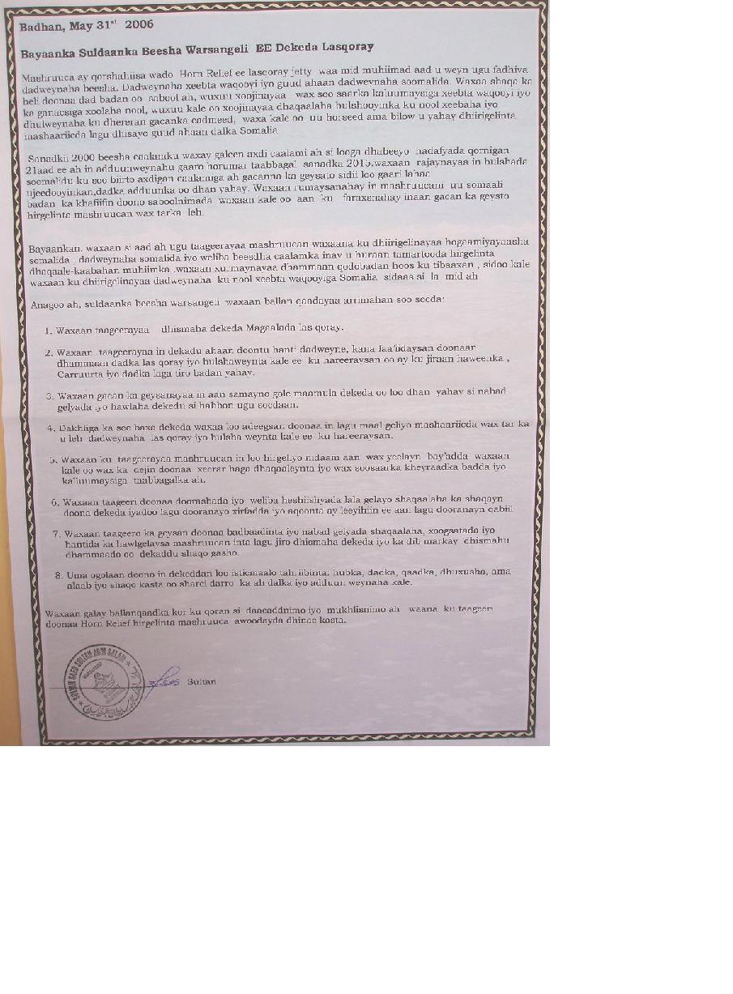

ANNEX A

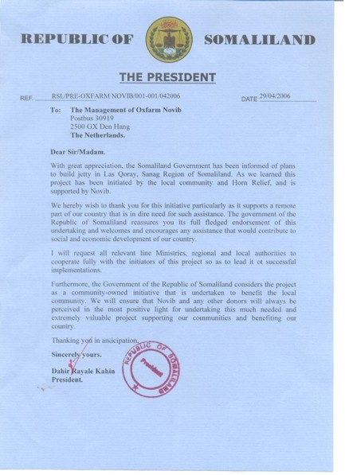

ANNEX A

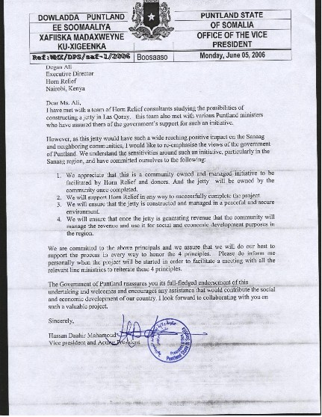

ANNEX A
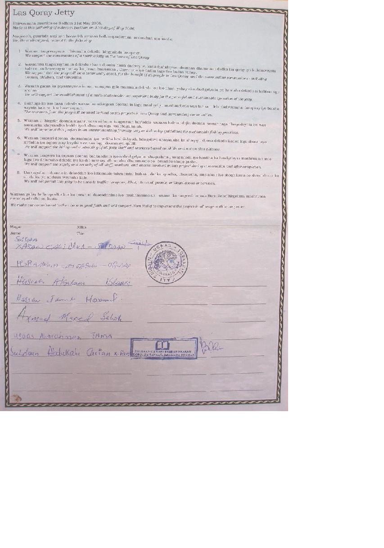

EX A

Las Qoray Jetty

Shirweynaha guurtida ee Badhan 31st May 2006.
Made at this gathering of elders in Badhan on 31st day of May 2006.

Anagoo ah, guurtida saxiixan hoose leh waxaan ballan qaadaynaa arrimahan soo socda:
We, the undersigned, commit to the following:
- Waxaan taageeraynaa dhismaha dekeda Magaalada las qoray.
We support the construction of a marine jetty in the town of Las Qoray.
- Waxaannu taageeraynaa in dekadu ahaan doontu hanti dadweyne, kana faa’iidaysan doonaan dhammaan dadka las qoray iyo bulshaweynta kale ee ku hareeraysan oo ay ku jiraan haweenka , Carruurta iyo dadka laga tiro badan yahay.
We support that the jetty will be a community asset, for the benefit of all people in Las Qoray, and the surrounding communities - including women, children, and minorities.
- Waxaan gacan ka geysanaynaa in aan samayno gole maamula dekeda oo loo dhan yahay si nabad gelyada iyo hawlaha dekedu si habbon ugu socdaan.
We will support the establishment of a multi-stakeholder management body for the peaceful and sustainable operation of the jetty.
- Dakhliga ka soo baxa dekeda waxaa loo adeegsan doonaa in lagu maal geliyo mashaariicda wax tar ka u leh dadweynaha las qoray iyo bulsha weynta kale ee k u hareeraysan.
The revenues from the jetty will be used to fund social projects in Las Qoray and surrounding communities.
- Waxaan u hirgelin doonaa mashruucan nidaam taageersan bay’adda waxaan kale oo dejin doonaa xeerar haga dhaqaaleynta iyo wax soosaarka kheyraadka badda iyo kalluumaysiga taabbagalka ah.
We will implement this project in an environmentally friendly way and develop guidelines for sustainable fishing practices.
- Waxaan taageeri doonaa doorashada iyo weliba heshiishyada lala gelayo shaqaalaha ka shaqayn doona dekeda iyadoo lagu dooranayo xirfadda iyo aqoonta ay leeyihiin ee aan lagu dooranayn qabiil.
We will support the hiring and contracting of all jetty staff and workers based on skills and not on clan alliance.
- Waxaan taageero ka geysan doonaa badbaadinta iyo nabad gelyada shaqaalaha , xoogsatada iyo hantida ka hawlgelaysa mashruucan inta lagu jiro dhismaha dekeda iyo ka dib markay dhismahu dhammaado oo dekaddu shaqo gasho.
We will support the safety and security of all staff, workers, and assets involved in this project during construction and after completion.
- Uma ogollaan doonno in dekeddan loo isticmaalo tahriibinta: hubka , dadka, qaadka, dhuxusha, ama alaab iyo shaqo kasta oo sharci darro ka ah dalka iyo adduun weynaha kale.
We will not permit this jetty to be used to traffic: weapons, Khat, charcoal, people, or illegal goods or services.
Waxaan gallay ballanqaadka kor ku qoran si daacaddnimo iyo mukhlisnimo ah waana ku taageeri doonaa Horn Relief hirgelinta mashruuca awoodayada dhinac kasta.
We make our commitment to the above in good faith and will support Horn Relief to implement the project in all ways within our power.

ANNEX B

This community theatre piece came as a surprise to Horn Relief. It was conceived and produced to be included in the commemoration ceremony for graduates of Sinai Primary School in Badhan, Sanaag. While one of our staff was attending the ceremony, the students began their impression of the importance of the Jetty and issues of access and use. We asked the students for a transcript of their production and we had it translated into English. Horn Relief is delighted at the initiative the students took to portray community values in relation to the Jetty.

Badhan, June, 3.06

This role play made by the young students of Sinai primary school in their school year closing ceremony.

The location is a town sea port, there are boats and ships carrying the goods, many people are also there including; traders and port management officers. This port is under the control of Galool community who claims that this port is built in their town.

Mr Du’ale from Maygaga community and his friend Qawdhan were getting in to the port gate and each one had some business to do there.

Mr Qawdhan: Asalaama calykum, how are you Sir?
Mr Du’aale: My friend, I came here to get my car out of the port, which is in the custom. I bought it from Dubai. Since yesterday, I have been trying to have my car out of the port but they asked me to pay much tax almost double above normal!
Mr Qawdhan: Oh! You know Du’ale, this Galool community are treating people so bad their approach is unkind and disrespectful. I also have some goods here but I cannot afford much taxes as they want.
Port police: Hey man, why don’t you pay the taxes? Such a minority people like you cannot refuse to pay the taxes and as much as we want! Go and pay now!
Du’ale is paying the taxes with very disappointed mood and feels he is over run.

Mr.Arraale is coming to the port, he is from Galool community.
Policeman: Hay, Arrale how are you? What business do you have to day in this port?
Mr. Arrale: Yeah. I bought a new land cruiser so it’s in the port now.
Policemen: Why don’t you take out of the port?
Arrale: I’m going to take out of the port today but I want to have it free of taxes.
Policeman: you right, you belong to us, go to custom officer he is one of the our kinsman, Called Garas,
Mr. Arrale: all right.
Mr. Arrale: coming to the custom office, Salaam calykum , Garas I haven’t known that you are the officer in charge here, I have my new car here and I want you to release it without paying taxes
Custom officer: this is yours Arrale, no body can refuse you this, and you can take your car out
Custom officer: talking to the office clerk, release Arrale’s car and don’t ask him any custom tariffs
Clerk:, ok, boss, hey policeman”, release this man with his car without asking any documents

Role play 2
The location is Town check point; there are many trucks loaded with various goods and from different regions

Truck 1: (belong to Galool community) Biib Biib hay you guys remove this bar, I’m hurry, I want to get in to the town soon.
Policeman: Oh, are you Godir? I thought you are those people of Maygag community. I have been waiting for those guys to come to charge more taxes.
Driver: Those trucks of Maygaag community and others are behind me so remove this bar for me and then go and take double charge from them .
Police officer: hey you, release him don’t you know him, sorry Godir he don’t know you.
Truck 2 :( loaded with hay fro animal feeding) these are Maygag community, Get down and go and pay the tax.
Driver: how much
Policeman: One million so,sh.
Driver: are you mad, even the price of this grass isn’t one million.
Policeman: that is your business you have to pay that amount other wise you will not pass through.
Driver :( borrowing some money from few passengers), sorry what should we do, these People of Galol community are oppressive. Take it, he pays and obeys the order.

Role play 3

To discuss this issue |Maygaag community have planned to meet in Badhan
(sultans, chiefs, Elders, women, youths, Diaspora): we cannot endure the way this people treat other people who use the port, we have long sea cost, let us organize and mobilize our community and resources and find out ways to rehabilitate our jetty in Lakorey for these poor traders and community. If we organize our effort and ask assistance our friends and international community we can rebuild our old jetty

The port got built and started its operations peace fully and was well managed.

Members of Maygaag community came to Jetty authority officer and asked: We want to know the rules and regulations of the jetty
Port officer: the rules have been set up by the traditional leaders and the jetty users are equally respected
Two community members: that is great, thank you, we want this to be open to every community and rules are equal for all;
Port officer: don’t worry; we take care of all and every one user equally and fairly. Any complains we like too listen and try to improve services to the customers satisfaction.
Community members: thank you and good luck, bye

A trafficker came to the port and asked a port officer there:
Trafficker:: salaama calykum sir;
Port officer: Wacalaykum salaam
Trafficker I brought 320 people from far away regions included Ethiopia I want this people to send to Yemen
Port officer: hey man, this kind of things is not allowed, trafficking people, weapon, charcoal and all illegal things, I will call police now
Trafficker, he runs away,

ANNEX C

Photographs from the community meeting.
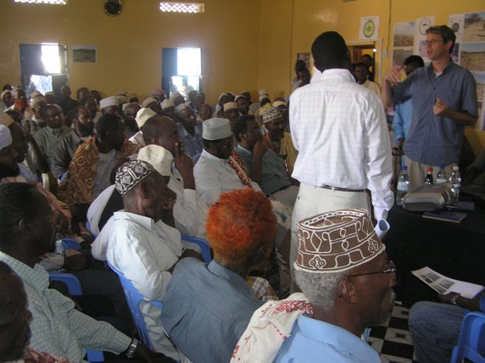
Presentation to Sultans, Chiefs, and Elders

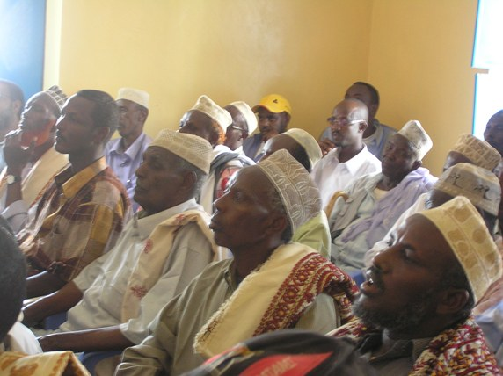

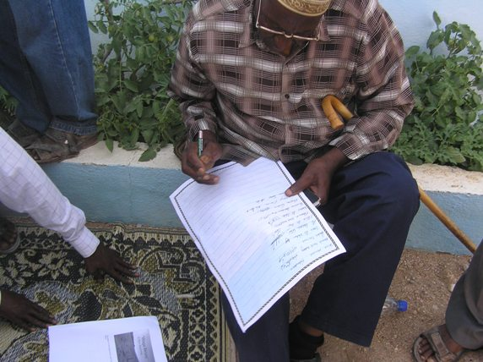
Elders sign Jetty declaration

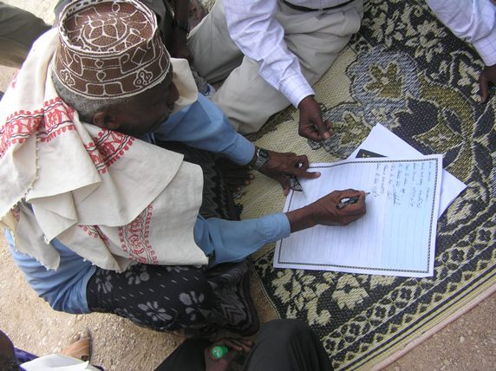

ANNEX D

Presentation at community meeting.
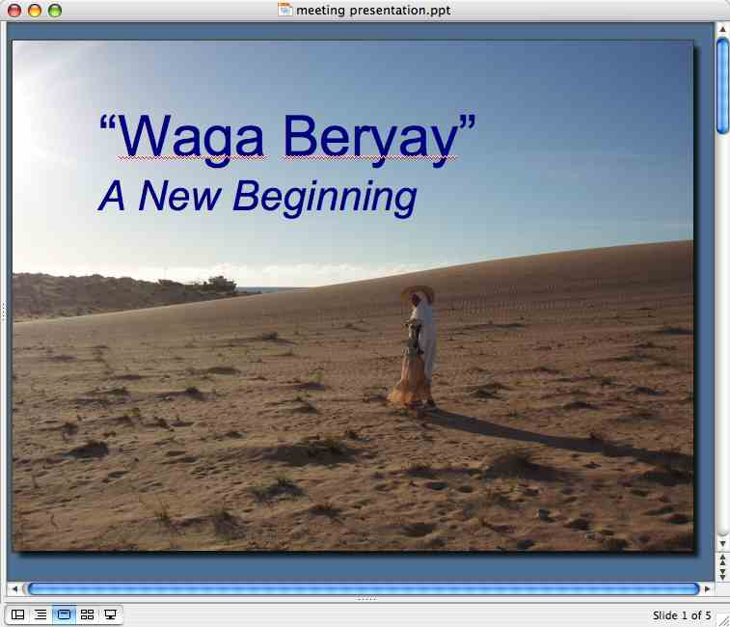
The Jetty is a new beginning for Las Qoray and the people living in the North.
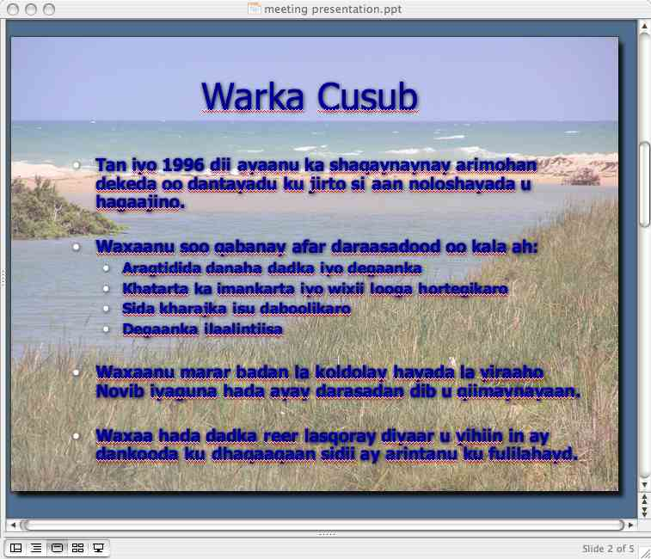
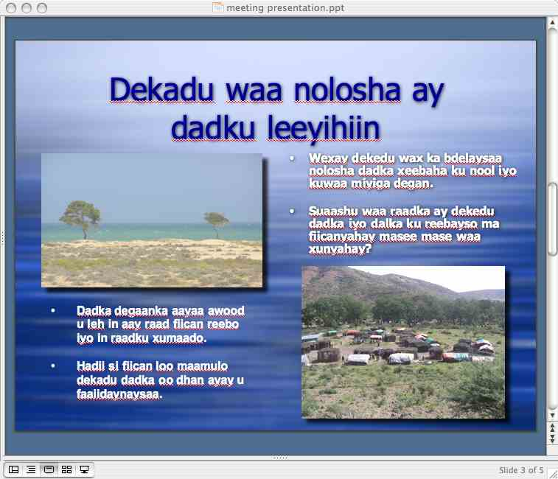
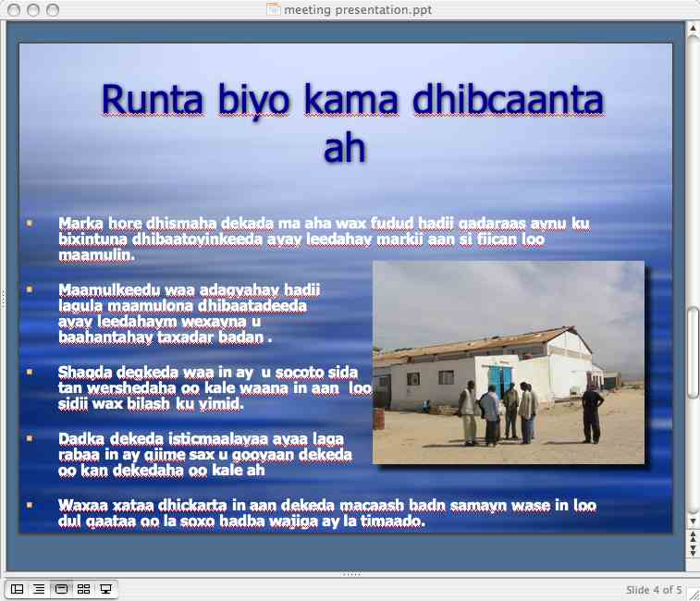
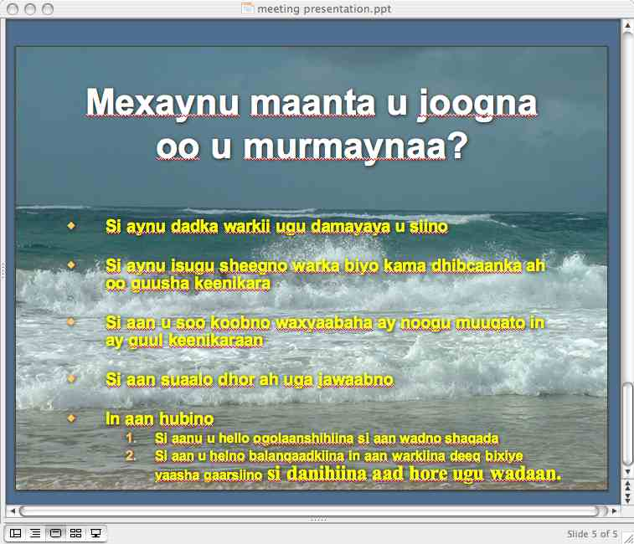
UPDATE
We (the community of Las Qoray with Horn Relief) have been working on this project since 1996
We have commissioned professional assessments/studies
i. Feasibility
ii. Risk Analysis
iii. Environmental
We all now have a unique opportunity to be proactive and persuasive with potential donors

JETTY = “PUBLIC GOOD”

The Jetty will have a profound effect on coastal and inland communities. The only question is, will the effect be positive or negative?
We (this community, elders, governments, Horn Relief, etc.) can do a lot to determining this outcome.
The Jetty will be benefit a large constituency and will represent a community asset – it must be managed as such.
REALITY CHECK
- It will be difficult to obtain funding from donors for this project
- Construction will be challenging and tendering for contracts will have to managed carefully
- Management (if the project goes forward) will be challenging and co-management of resources is fraught with complications
- Jetty must be run as a business, not a free service
- Users of the facility must expect to pay industry-standard handling and in/out charges
- Jetty may not be “profitable” – the benefits/profits may not come – management, market forces, etc. will determine this.

WHY ARE WE TALKING TODAY?

- To keep the community up-to-date on progress
- To provide a “realty check” of the chances for success
- To outline what we feel will be needed for success
- To answer questions
- To secure:
- Your approval to continue and your commitment to voice support to donors

ANNEX E

Graeme Watson Associates
P. O. Box 49134
Nairobi 00100
KENYA

9th June 2006

Ms Degan Ali
Deputy Director
Horn Relief
P. O. Box 70331
Nairobi 00400

Dear Degan,

Re: Feasibility Study for Construction of a New Jetty and Berthing Facilities at Las Qoray, Sanaag Region, Northern Somalia
Response to Comments made in Technical Review of Draft Report

Thank-you for forwarding the Report of the Technical Review carried out by DHV on the Draft Technical Report for Laasqorayas submitted by GWA in January this year. For your information DHV is a well established Dutch engineering company with experience in port design and I would consider its comments to be a positive contribution towards the overall design of the facilities at Laasqoray.

I have referred the Review to both Andrew Burnard and Duncan Hamilton. With regard to the principal comments made by DHV we would respond as follows:

- In Section 1.2 Summary of Findings DHV conclude that: (i) GWA “succeeded in bringing together the basic data, on which a preliminary design could be made”; (ii) “the recommended structure type….is supported by DHV”; and (iii) in regard to the GWA recommendation that a geotechnical survey be carried out “We strongly support this recommendation”. The conclusion of the Review is therefore that both the location of the berth and the method of civil construction proposed are supported by DHV.

- In the same section, DHV go on to raise many technical issues for which they state further work is required and, by so doing, give the impression that the Feasibility Report may be deficient in these respects. Careful reading of the text, however, makes clear that these issues should be addressed during the detailed design stage, a fact that is covered in the Feasibility Report which makes clear that further investigations and a detailed design will have to be carried out as part of the Final Design before the facility can be tendered out and constructed.

With regard to the more specific comments made by DHV we would respond as follows:

Section 2.1 Location of berth: Agreed by DHV

Section 2.2.1 Target ships: DHV comment on the lack of definition of dimensions of target ships in the report, but conclude that these should be defined “before going on to the detailed design stage”. However, they appear to be agreeing with our basic assumptions.
Section 2.2.2 Cargo volume throughput: DHV agrees with the basic layouts proposed and, despite some discussion on the subject, concludes that “the number of berths ….is in line with the expected cargo….and the number of ships expected” and that the “total basin area is sufficient”. Separate fishing boat berths can be accommodated.

Section 2.2.3 Tide: DHV make a number of valid comments with respect to the tide and tidal depths to be assumed. We agree that further tidal variations should be computed and that, if the use of the port by large vessels is restricted at periods of low water, the amount of dredging can be reduced. For the purposes of the Feasibility Study our assumption has been conservative. As concluded by DHV, these assumptions can be refined and optimised “before final design is started”.

Section 2.2.4 Waves and current: Our conclusions on waves and current are supported by DHV, though we agree that a more detailed study on waves to assess the requirements for protection of the berths and the effects of sedimentation should be carried out before the final design is undertaken.

Section 2.2.5 Geotechnical data: DHV strongly support our recommendation that a geotechnical survey be undertaken “before detailed design is started”.

Section 2.2.6 Rock materials: Section 3.4.1 of the Feasibility Report made clear that large rocks are plentifully available in the locality. These rocks are large enough to provide the protection required. However, a comparison should be made at detailed design stage between the use of rocks and concrete units for these protection works.

Section 2.3.1 Layout of facility: DHV confirm that the “layout of the facility is suited to provide safe berthing of the vessels”.

Section 2.3.2 Construction type: Our design principles are agreed by DHV and we agree with their comments.

Section 2.3.3 Typical cross section:

Crest level:
We agree that this level should be “verified during detailed design” and that the crest height should be determined on the basis of the detailed wave studies during detailed design.

Dredging level:
Again, it is agreed that, should access by vessels be acceptable less than 100% of the time, the dredged depth could be reduced. The options to be considered in this regard should be agreed in detail and optimised at the detailed design stage.

Rock layer:
The comments made by DHV are agreed. As indicated above, the protection requirements should be analyzed in detail and the optimum solution adopted during detailed design stage.

Block wall structure:
DHV have agreed our principles, but we are not sure from where they have obtained the rule of thumb that requires the base to be equal to the height. The base widths of most walls in published literature are of the order of 50% of their heights, whilst a study by ourselves of walls which have stood the tests of time from 1885 onwards indicates base/height ratios ranging between 0.39 and 0.54. The lattermost applies to one of the berths in Mombasa.

For the purpose of preliminary design and quantity estimation we have adjusted the base/height ratio to 0.7 in response to the comment made to ensure conservative cost estimation.

Pavement area on the jetty:
DHV’s comments are agreed. Once again these are issues which should be addressed in the detailed design stage after completion of the detailed wave study.

Mooring provisions:
Bollards will be indicated on the drawings, though the detailed design of these will be part of the final design of the structure.

Section 2.4 Quantities and Cost Estimates:
The quantities and cost estimates provided for Layouts 6 and 7, which you have indicated are your preferred options, have been reviewed and revised taking into account adjustments made in response to DHV’s comments and amended estimates prepared for Phases 1 and 2 of these options. The adjustments made include the following:

- The base of the reinforced concrete wall structure has been increased to 0.7 x its vertical height.
- The berth and rock protection levels have been raised from + 4m to + 5m.
- A protection layer of rock 0.5m deep has been allowed for where the filter membrane and toe of the slope protection enter the sea bed.
- The main embankment fill has been changed from rock to sand fill, with consequent saving. Such an arrangement also makes available the option of using the dredged material for embankment construction which would have environmental as well as cost benefits.
- The dredged depth of the port entrance for Phase 1 has been reduced from -4.0m to -3.5m on the basis of restricting entry and exit of ships at LWOST, whilst that for Phase 2 has been reduced from -6.0m to -5.5m.
- In the Phase 2 estimate, allowance has been made for protection of the sea bed inside the port against scour by vessels’ propellers.
- Provision has been made for the costs of the geotechnical investigations, as well as specialized inputs to the wave and sediment transport studies. An allowance of $ 250,000 is considered necessary for these in Phase 1.

DHV make the comment that “unit rates are difficult to verify”, which case is particularly difficult in Somalia where it has not proven possible to obtain an independent estimate of what percentage risk factor a contractor is likely to add to his price. Their comment that the dredging cost appears high has been disregarded as, whilst in Europe a company may hire a crane and pontoon cheaply, this may not be the case on the Gulf of Aden where ordinary commercial rates have no meaning. The rate we have used was established on the basis of quotation, which has subsequently been reconfirmed.

On the basis of these adjustments the estimated construction costs (excluding the costs of purchasing cranes) for Phases 1 and 2 adopting layouts 6 and 7 respectively calculate as follows:

- Phase 1: US$ 5,567,024
- Phase 2: US$ 7,980,312

Though not specifically commissioned to review the economic feasibility analysis, DHV have made a number of comments which I respond to below:

- They suggest that we may have underestimated the number of vessels required for livestock. In addressing this aspect Duncan Hamilton took the loadings from the Berbera and Bosasso studies he had previously carried out for the EU, which had involved implementation of vessel surveys. However, historic data for livestock exports for Laasqoray show that livestock are moved both in vessels dedicated for livestock and in vessels otherwise carrying general cargo. Dividing the number of animals exported by the number of livestock vessels will therefore produce a figure for average loads greater than a dedicated vessel can carry. The prospect that some livestock may be carried on general cargo vessels (as cargo in hold or livestock on deck) may explain the apparent underestimation of the number of livestock vessels and overestimation of average head per vessel.

- The effect of increasing the number of livestock vessels on the economic appraisal will be zero. On the financial appraisal, there will be an increase in revenues from vessel charges, whilst revenues from livestock handling will remain unchanged.

- Whilst an increase in the number of vessels could be expected to have a bearing on the port design capacity, DHV have concluded in Section 2.2.2 that the number of berths is in line with the expected cargo volume.

- DHV comment in Section 2.1.1 that the predicted cargo flows seem to have a “small basis…..without quantitative study”. Whilst such a statement would be true for cargo flows based on Berbera, it is not true for flows based on Bosaso. We identified and quantified cargo and livestock currently going through Bosaso which would divert to Laasqoray on the basis of savings in inland transport costs and not on the basis of “patriotism” of local investors.

With regard to the queries raised by you by satphone on 8th June, I would clarify as follows:

- The difference between the budgets presented in the cost summaries in Section 4.4 for Layouts 6 and 7 and those in the Conclusions section of the Executive Summary is that the former include the costs of acquiring mobile cranes (US$ 500,000 and US$ 200,000 respectively), whilst the latter cover the civil construction costs only. The costs including mobile cranes were taken as being the project costs for the purposes of the economic feasibility analysis. In executing the project, however, it may be decided to rent the necessary cranes from the private sector, in which case they would become part of the operating costs.

- Having reviewed the estimated costs contained in the draft report on the basis of the comments received from DHV and on the basis of our internal review of the design, the estimated construction costs have been adjusted as described in Section 2.4 above. The costs presented exclude the provision of mobile cranes, but include the estimated costs for carrying out the geotechnical investigations (in Phase 1), which had not been included in the earlier estimate, and the design and supervision of the works by a consulting engineer. It should be noted that, whilst the estimated costs are higher in dollar terms, they may not be higher in terms of other currencies such as the Euro.

- The 15% provision for contingencies is an allowance to cover physical and/or technical contingencies for untoward conditions encountered during the period of design and construction. In addition to this, the Client and/or funding agency should make provision for an overall project contingency in accordance with his/her normal procedures for budgeting purposes, to cover anticipated risks associated with the overall commissioning and development of a donor-funded project of this nature, including currency fluctuation.

I hope that my responses cover all the issues that DHV have raised as well as your queries. With regard to completion and finalization of the report, I shall be in a position to make a start this coming weekend, with a view to completing it two weeks from today. The report will be revised to take into account all the issues identified above, whilst the economic and financial analyses will be updated to reflect the amended costs. Should you have any further observations and comments, please forward them to me as soon as possible so that they can be addressed in the final version of the report.

Yours sincerely,

Graeme Watson

PHASE NO. 1 : WITH DEEPENING BY DREDGING
No. | Description of work | Unit | Quantity | Rate | Amount
 |  |  |  | USD | USD
1 | Dredging for deepening | cum | 50,000 | 11 | 550,000
2 | Dredging for berth structures | cum | 5,300 | 11 | 58,300
3 | RC berth structures | cum | 5,500 | 300 | 1,650,000
4 | Stone fill to berth structures | cum | 5,500 | 15 | 82,500
5 | Sand fill | cum | 30,000 | 5 | 150,000
6 | Filter membrane to fill slopes | sqm | 6,000 | 5 | 30,000
7 | Rock protection to fill slopes 1.5 m thick | cum | 8,750 | 20 | 175,000
8 | Filter membrane to sea bed | sqm | 3,000 | 5 | 15,000
9 | Rock protection to sea bed | cum | 1,500 | 20 | 30,000
10 | Stone sub base to apron 0.4m thick | cum | 2,600 | 20 | 52,000
11 | Lean concrete base to apron 0.2 m thick | cum | 1,200 | 200 | 240,000
12 | 80 mm concrete blocks | sqm | 6,000 | 35 | 210,000
13 | Fenders, fixed | no | 62 | 1,000 | 62,000
14 | Fender, pneumatic | no | 4 | 5,000 | 20,000
15 | Geotechnical investigations |  |  |  | 250,000
16 | Design and supervision |  |  |  | 485,000
17 | Add for fittings etc |  |  |  | 50,000
18 | Total work Items |  |  |  | 4,109,800
19 | Add 20% Preliminaries |  |  |  | 821,960
20 | Add dredger fixed costs |  |  |  | 170,000
21 | Sub total |  |  |  | 5,101,760
22 | Add15% Contingencies |  |  |  | 765,264
 | TOTALS |  |  |  | 5,867,024

PHASE NO. 2 : WITH DEEPENING BY DREDGING
No. | Description of work | Unit | Quantity | Rate | Amount
 |  |  |  | USD | USD
1 | Dredging for deepening | cum | 56,500 | 11 | 621,500
2 | Dredging for berth structures | cum | 6,028 | 11 | 66,308
3 | RC berth structures | cum | 9,614 | 300 | 2,884,200
4 | Stone fill to berth structures | cum | 9,614 | 15 | 144,210
5 | Sand fill | cum | 93,840 | 5 | 469,200
6 | Filter membrane to fill slopes | sqm | 7,650 | 5 | 38,250
7 | Rock protection to fill slopes 1.5 m thick | cum | 12,000 | 20 | 240,000
8 | Filter membrane to sea bed | sqm | 6,500 | 5 | 32,500
9 | Rock protection to sea bed | cum | 3,250 | 20 | 65,000
10 | Stone sub base to apron 0.4m thick | cum | 1,500 | 20 | 30,000
11 | Lean concrete base to apron 0.2 m thick | cum | 700 | 200 | 140,000
12 | 80 mm concrete blocks | sqm | 3,200 | 35 | 112,000
13 | Fenders, fixed | no | 27 | 1,000 | 27,000
14 | Fender, pneumatic | no | 4 | 5,000 | 20,000
15 | Add for fittings etc |  |  |  | 50,000
16 | Design and supervision |  |  |  | 701,000
17 | Total work Items |  |  |  | 5,641,168
18 | Add 20% Preliminaries |  |  |  | 1,128,234
19 | Add dredger fixed costs |  |  |  | 170,000
20 | Sub total |  |  |  | 6,939,402
21 | Add15% Contingencies |  |  |  | 1,040,910
 | TOTALS |  |  |  | 7,980,312

Notes:
- In the Phase 2 estimates, protection of the seabed inside the Port against scour by vessels' propellers is considered.
- Notwithstanding the comments made in 6 of DHV's Summary of findings, dredging up to -5.5 m CD is provided.
- There is a greater percentage increase (about 25%) in the revised Phase 2 estimate compared to that for the Phase 1 exercise (about 15%) due to the effects of raising the berth surface level to +5.0 m CD in the deeper water of the Phase 2 development.

ANNEX F

Individuals who have committed to supporting the Jetty project.

America
SN | Name | Location
1 | A/Qaadir Hirsi Faroole | Calif
2 | Hassan Warsangeli | ATl
3 | Mahamad Garad | Meryl
4 | Mahamad Jama Jibril | MN
5 | Mahamad Ali D JIbril | NY
6 | Mahama Ali Geldon | ATL
7 | Mahamoud Ali Geldon | ATL
8 | A/kadir Ibrahin Salah | TUWI
9 | Abshir Musa Ashur | TUSAN
10 | Ali Ahmed Fatah | Wash D C
12 | Osman Duale Jibril | M N
13 | Mahamed Abdi qaac | MN
14 | Sirad Haji Abdi | MN
15 | Seynab jama Qorshel | Mn

Canada
SN | Name | Location
1 | Abdi Mahamad Jarig | Otawa

Europe
SN | Name | location
1 | Ali Salah Isse | liverpool
2 | Dahir Farah Ade | liverpool
3 | Aamina Jama Nouh | liverpool
4 | Abdi Mahamed Salah | London
5 | Ruqiyq Jama Nouh | London
6 | Hawa/sahra Mahamoud Abdala | London
7 | Hassan Mahamed Salah (somali) | London
8 | Mahamad Issmail Abdi Fatah | Denmark
9 | Abdi Jibril | Holland
10 | Mahamoud Ali Salah | Saudia

Individuals who are being approached as part of our “Outreach Strategy”

SN | Name | Location
1 | Omar Abdi Ali Bair | Geneva
2 | Ismail Abdi Ali Bair | Balta USA
3 | Ismail Mahamoud Ali Bair
4 | Jama Mahamoud Ali Bair | Canada
5 | Ahmed Mahamoud Ali Bair | Canada
6 | Mahamoud Abdi Fatah | USA
7 | Alien Adi fatah | USA
8 | Ali Ahmed Fatah | Wash
9 | Salah Ahmed Fatah | USA
10 | Mahamoud A/lahi Fatah | USA
11 | Yassien Abdulahi Fatah | Mn
12 | Ruqiya Ahmed Fatah | MN
13 | Zinab Ahmed Fatah | MN
14 | Salah Bulhan | MN
15 | A/Rizak Bulhan | MN
16 | Mohamed Bulhan | MN
17 | Said Ahmed Haji Salah | scandanafian
18 | Hodon Ahmed Ayan | USA
19 | Mahamed Ahmed Salah | USA
20 | Mahamad Hassan Ade | Saudia
21 | Hawa Hassan Ade | ATL
22 | Habiba Hassan Ade | ATl
23 | Gacamey Mahamed Findhe | London
24 | Ali Mahdi Mahamed Findhe | UK
25 | Ibrahin Findhe | UK
26 | Yaquub Ibraahin Findhe | UK
27 | Mahamed mahamoud mahamed Shire | USA
28 | A/lahi Mahamoud mahamed Shire | USA
29 | Mahamed Ismail Ashur | UsA
30 | Mahamoud Omar Ashur | USA
31 | Dahir Hji nour & sons | USA
32 | Mahamoud Isse Aar | USA
34 | Mahamed M J Jibril | USA
35 | Degan Ali Bair | Nairobi
36 | Ayan A/rahman Ali bair | Mn
37 | Maria A/rahman Ali Bair | Mn
38 | Aamina Ahmed Ali & Family | MN
39 | Sahra Mahamed Ali | MN
40 | Seynab Mahamed Ali | MN
41 | Bood & his family | Canada/UsA
42 | Hassan Karani | Saudi
43 | Yusuf Farah Sigar &family | USA
44 | Sugule &Family | Saudi
45 | Ali Booh brothers& family | USA
46 | Ali Ade & Family | USA
47 | A/lahi Jibril
48 | Mahamed Hassan Ali Maah | USA
49 | Yusuf Ali Fanah | UK
50 | Said Salah Ahmed | Uk
51 | Ibraahin Aw Aduur | UK
52 | Said A/lahi urcad | Uk
53 | A/rahman Mahamed Isse | UK
56 | Dhega weyne mahamed Hassan | Canada
57 | Ibraahin Wahaabi | UK
58 | Mahamed Abdi Ali Maah | USA
59 | Mahamed Awed Suldan | europe
60 | Abdala Ahmed Hirad | USA
61 | Mahamed Mahamoud Isse
62 | Indhadeeq Soomajeeste | Mn
63 | Ali Mahamed A/karin | JICgo
64 | Mahamed A/lahi Qablan | Uk
65 | Hassan Hanshariye | Jicago
66 | Jama Omar Ahmed | Manjester
67 | Mahamed Ahmed (head tuulo) | Denmark
68 | Daarood ismaaciil | Denmark
69 | Cismaan Cabdale Mataan | liverpool
70 | Faaduma Jaamac Giriig | London
71 | C/raxman Ahmed SH SAlah | Sweden
72 | Eng nuuh Aw Yusuf | manasota
73 | Sheeywaal Mahamed Hassan | manasota
74 | A/ rashiid Ali Warsame | manasota
75 | A/laahi mahamed Farah | ustrali
76 | Farduus Mahamed Farah | ustrali
77 | Ali abdi | manasota
78 | Ahmed A/qadir Mahmed Isse | London
79 | Farxaan c/qadi Mahamed Isse | holland
80 | Ahmed Yasin Shiikh | Denmark
81 | Said jama giriig | Denmark
82 | Imail Somali | UK
83 | Feysal Ali Hashi | USA
84 | A/Rahman yasin Shiikh | kuwait
85 | Feysal Xawar | UAE
86 | Ismail Said Botan | Kuwait

These non-profit corporations will be registered in both Puntland and Somaliland.
Socio-Political Conflict Assessment (Wachiira and Baffo), pp. 31, 33

